Report on the 2005 BC-ISMRM Meeting
St John’s College, Oxford, 31 August – 2 September

The 2005 BC-ISMRM meeting was held at St John’s College (Oxford) from 31 August to 2 September. The college’s secluded Garden Quad combined the auditorium and poster area, as well as providing a pleasant environment for coffee/tea breaks, and meeting corporate sponsors. The entire experience was further enhanced by the superb weather that was specially ordered for the meeting.
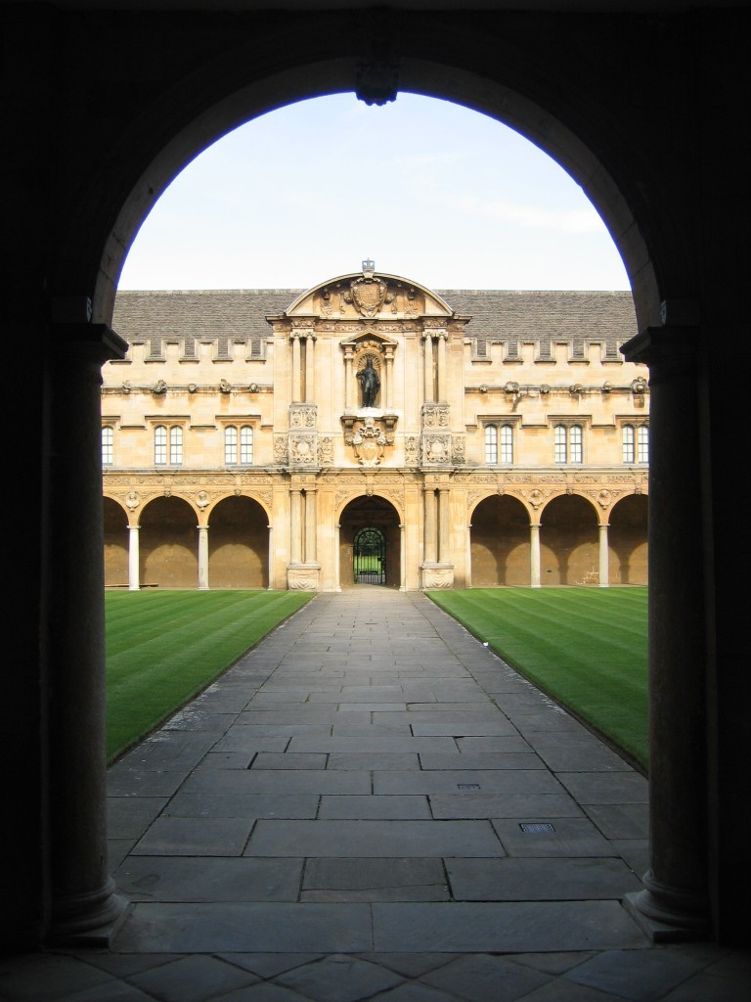

This year’s satellite workshop was organised by Chris Clark (St George’s Hospital) on the topic of Diffusion Tractography, and took place during the afternoon of 31 August. Numerous experts who work at the coalface of diffusion image acquisition and analysis passed on their gems of knowledge, helping to educate the wider BC-ISMRM community in this growing area. In the event over 70 people came to the satellite workshop, and Chris should be congratulated on arranging such a useful and timely session.

The Museum of the History of Science was the location for the subsequent opening reception for the main meeting. This was a new “venture” for the museum, and made a fascinating (if rather too hot) venue for such a gathering. A cooler respite was offered by a wander around the special exhibition of “famous scientists’ blackboard scribbles”, featuring among others a blackboard written on (and signed) by Albert Einstein.

The scientific meeting itself kicked off with the annual Bill Moore Memorial Lecture, given this year by Peter Morris from Nottingham University. Peter gave a gripping presentation of the many exciting projects that are ongoing in Nottingham, ranging from carbon 13 detection, to functional MRI and to combined magneto-encephalography. The other “special guests” at the meeting included Frank Shellock (University of Southern California, and sponsored by GE Healthcare) who reminded us of the need to be constantly vigilant in matters of MR safety, and Richard Buxton (University of California San Diego) who described how more sophisticated fMRI experiments can help us to probe physiology in the healthy and diseased brain. Finally, Reza Razavi described recent advances in cardiac imaging and interventional catheterization.

In addition to the above guest speakers we had a number of invited lectures from BC-ISMRM members, opening scientific sessions in Experimental Models; Sequence Design and Image Analysis; Cardiovascular and Angiographic MR; Advanced Neuro MR; Body MR; and Molecular MR and Novel Contrast Agents. The speakers included Mark Lythgoe (UCL), Karla Miller (Oxford), Margaret Hall-Craggs (Middlesex Hospital) and Jim Wild (Sheffield). Each invited talk was followed by proffered scientific presentations. It was particularly encouraging to see so many new entrants to the field giving these presentations – a sign that magnetic resonance in medicine is still as vibrant a research field as ever!

In a break from tradition, and as an experiment this year, we held a debate on the first day with the proposition “This House Believes that 7T will Never Transfer to the Clinic”. Roger Ordidge and James Byrne argued gallantly in favour of the proposition, comparing 7T with a Formula 1 racing car, that would unreliably provide spectacular performance on race day, but that would never be feasible as a routine clinical tool. Peter Morris and Paul Matthews argued against the proposition, stating that “never say never” and advocating the exciting potential of such a field strength. In the final vote it was clear that the proposition was defeated, although there was a sense that a stumbling block was the word “never” and that no-one expects a clinical transition in the short term. The final verdict, from feedback that I heard, was that the experiment was a valuable success and that much was learned in the light-hearted presentations and subsequent discussion. Thanks should go to Stuart Clare for organising the debate, ably assisted by Alistair Howseman.

Another “innovation” (although I am sure this has occurred before) was that we held a dedicated poster session following the Thursday afternoon tea break. This provided a combined 80 minute opportunity to meet poster presenters at their posters and to engage in scientific dialogue. Again, this experiment was warmly received, and helped redress the difference in presentation opportunities afforded to those who are given a talk rather than a poster (a complex and often arbitrary choice).

Another (ultimately less successful) experiment was the attempt to provide a more “clinically weighted” second day for the meeting in an attempt to attract busy clinicians to our meeting. We also offered a special 1-day pass to the second day. In the event, very few clinicians were able to come to the meeting – a long-standing problem that evidently still requires a solution. Regardless of this, the clinical presentations that did take place on the second day were all of a very high standard, and were combined with related basic science presentations that highlighted the impact that MRI has across many clinical disciplines.

Thursday evening found us in the splendid surroundings of the medieval dining hall of St John’s College. Over 150 delegates filled the hall to capacity, and sampled the traditional Oxford experience of enjoying good food and wine whilst getting a sore behind from sitting on uncomfortable benches. Fortunately the wine and port flowed sufficiently liberally to dull the pain, and a thoroughly enjoyable evening was spent by all. The dinner also provided an occasion to thank the conference secretary (Teri Kleinberg), and to congratulate the winner of the poster prize (Hannah Devlin). The potentially embarrassing fact that the poster prize winner selected by our totally independent and uncorruptible (honest guv!) poster prize committee turned out to be a student of the conference chair was gracefully ignored by the audience.

In summary and by all accounts the 2005 meeting was a great success, attracting more delegates than ever before. The meeting clearly continues to be a very valuable opportunity for the British MR community to get together in a relatively informal and low-key way, yet without compromising the scientific rigour that was amply demonstrated at this year’s meeting.

Finally, the BC-ISMRM Local Organising Committee was extremely grateful to receive corporate support from several companies who have a presence in UK magnetic resonance. These were: GE Healthcare and GSK (both at Gold Level support); Varian/Magnex (Silver Level support); and Bruker, Pulseteq, Siemens Medical Solutions and Philips Medical Systems (all at Bronze Level support). Their support helped make the event such an enjoyable and affordable experience, and also provided student stipend support (waived registration and travel fees) to 22 first-author PhD students of BC-ISMRM members.

I greatly look forward to the 2006 BC-ISMRM in Surrey, and wish Simon Doran every success in organising that meeting.

Peter Jezzard (Oxford LOC Chair)

On behalf of the other BC-ISMRM LOC members:
Chris Clark (Satellite Workshop organiser), Stuart Clare, James Byrne, Jane Francis, Paul Matthews, Stefan Neubauer, Matthew Robson, Nicola Sibson and Juergen Schneider.

